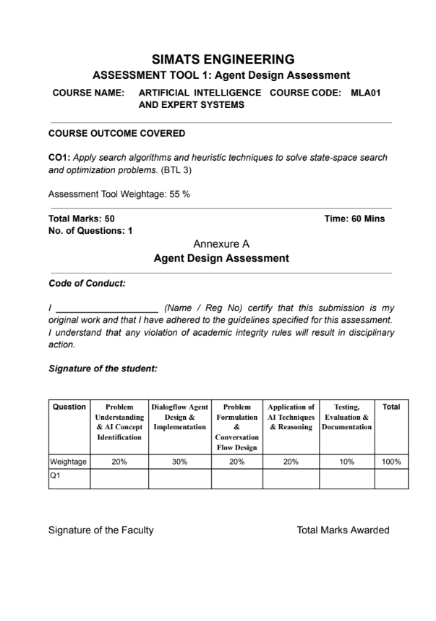
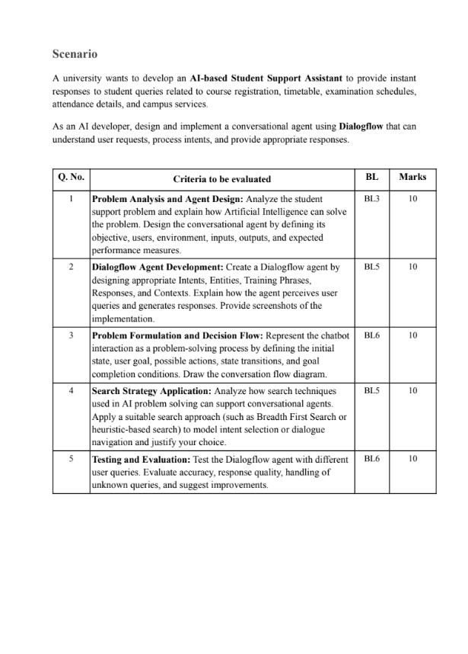

MLA0103-Artificial Intelligence with Expert Systems
Assesement Tool
Name: c.manogna sri hasitha Reg no:192525215

AI-BasedStudentSupportAssistantusingGoogle DialogflowES
Table of Contents:
Problem Analysis and Agent Design
Dialogflow Agent Development
Problem Formulation and Conversation Flow
Search Strategy
Testing and Evaluation
Conclusion
Problem Statement
Universities receive a large number of repetitive queries from students regarding course registration, class timetables, examination schedules, attendance details, library timings, hostel facilities, and other campus services. Students often have to contact faculty members or administrative staff to obtain this information, which can result in delays, increased workload for staff, and inconvenience for students. To address this problem, an AI-based Student Support Assistant is developed using Google Dialogflow ES. The chatbot provides instant, accurate, and automated responses to common student queries at any time, thereby improving communication and reducing administrative effort.
Agent Name: Student Assistant Type of Agent: Conversational AI chatbox
Google Dialogflow:
Google Dialogflow ES uses Natural Language Understanding (NLU) powered by Google's machine learning models. It identifies user intent and extracts entities from natural language queries to generate appropriate responses.
Environment:
The chatbot operates in an online environment using Google Dialogflow ES. It can later be integrated into university websites, mobile applications, or messaging platforms.
Inputs
The chatbot accepts text-based queries such as:
- How do I register for courses?
- Show my timetable.
- When are the semester exams?
- What is my attendance percentage?
- What are the library timings?
OUTPUTS:
The chatbot provides appropriate text responses such as:
- Course registration procedure
- Timetable information
- Examination schedule
- Attendance details
- Campus service information
Sensors
The chatbot receives user input through:
- Text entered by the student in the chat interface
Objectives:
The main objectives of the Student Support Assistant are:
- To provide instant responses to student queries.
- To automate frequently asked questions related to academic services.
- To reduce the workload of university administrative staff.
- To improve the availability of student support services.
- To provide accurate and consistent information 24×7.
Knowledge Base
The chatbot stores information related to:
- Course Registration
- Timetable
- Examination Schedule
- Attendance
- Library Services
- Hostel Information
- Medical Centre
- Transport Services

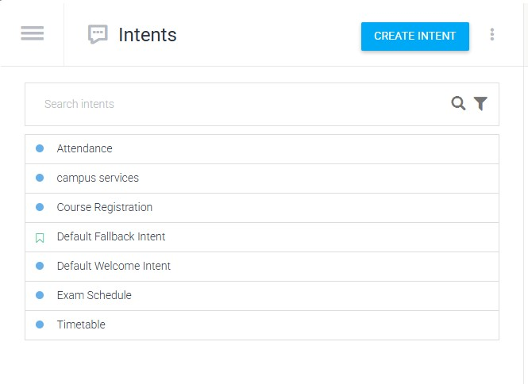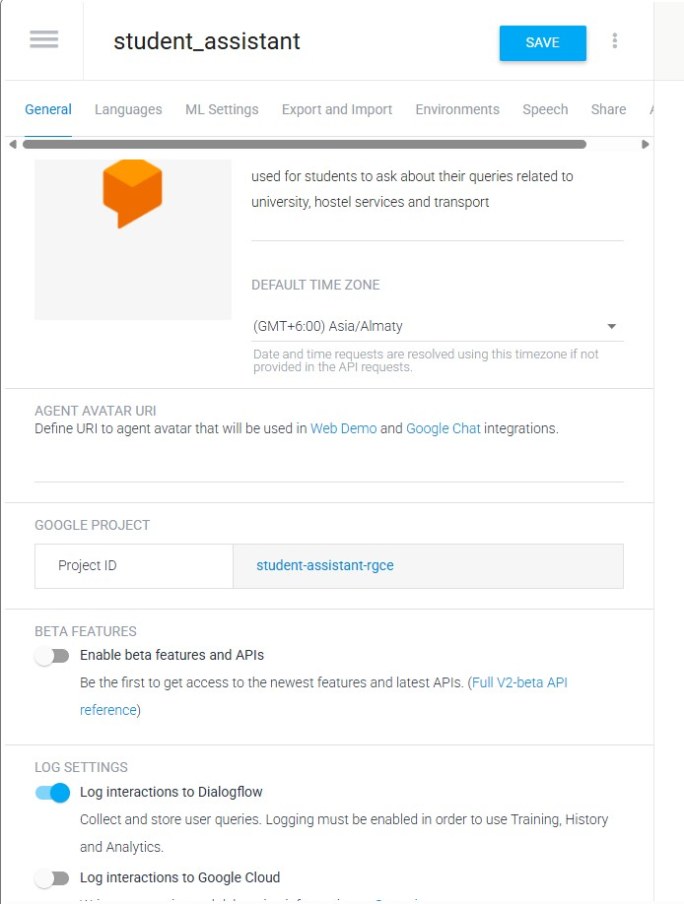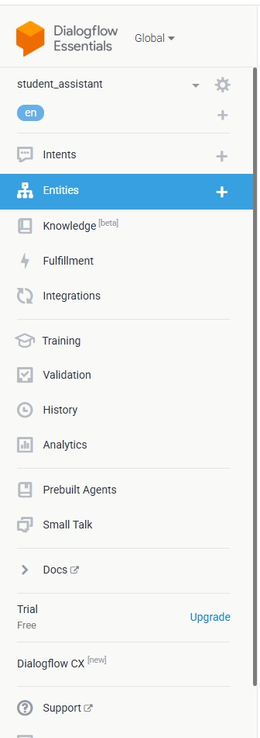
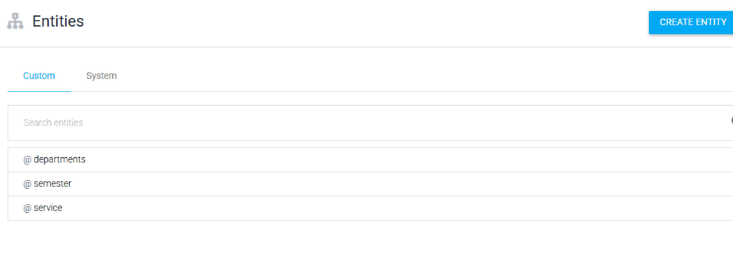
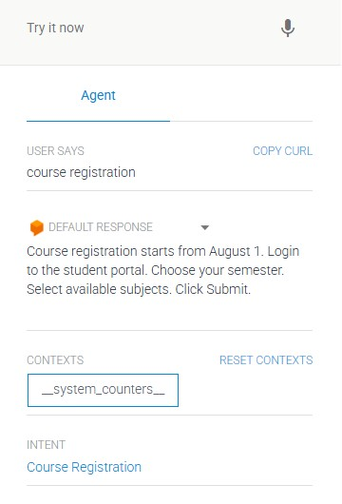
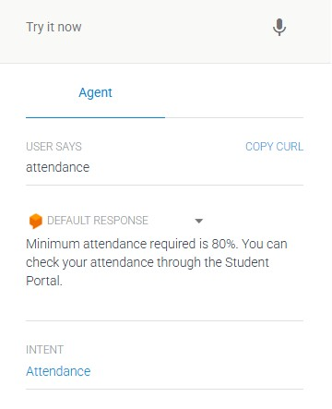
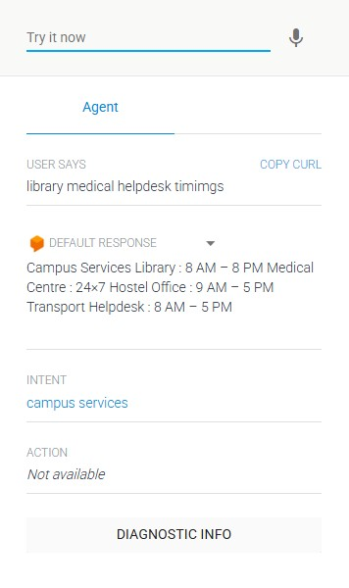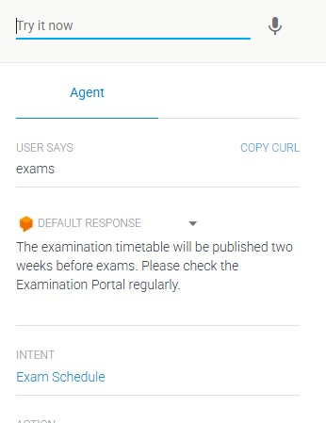
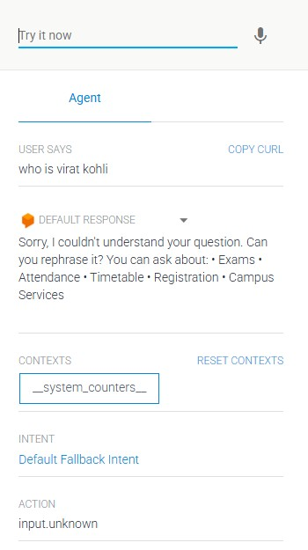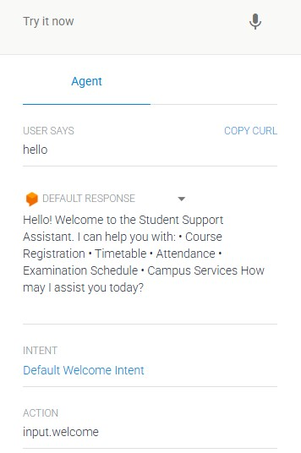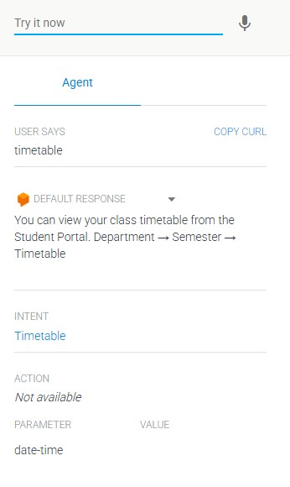
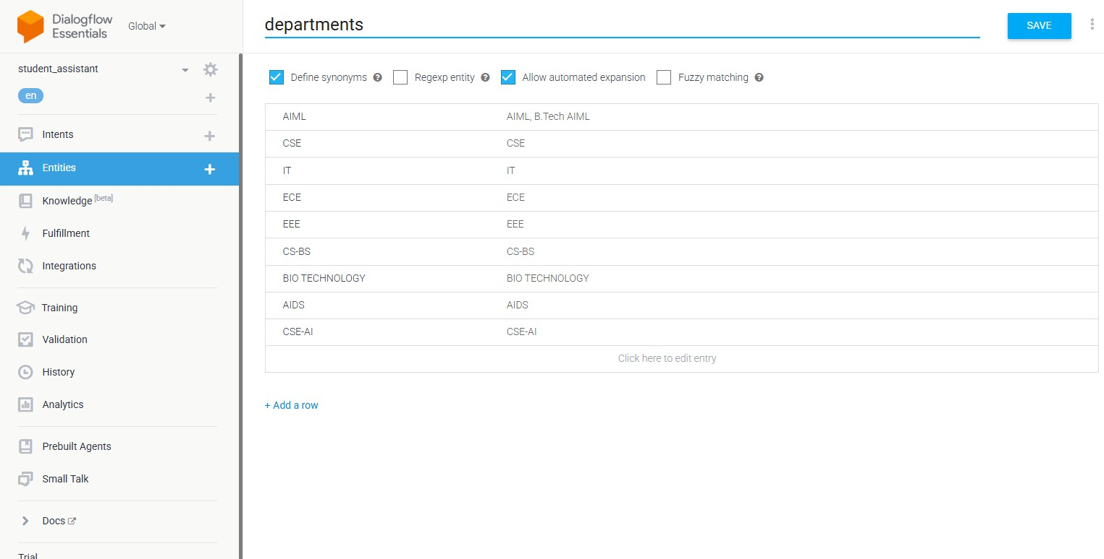
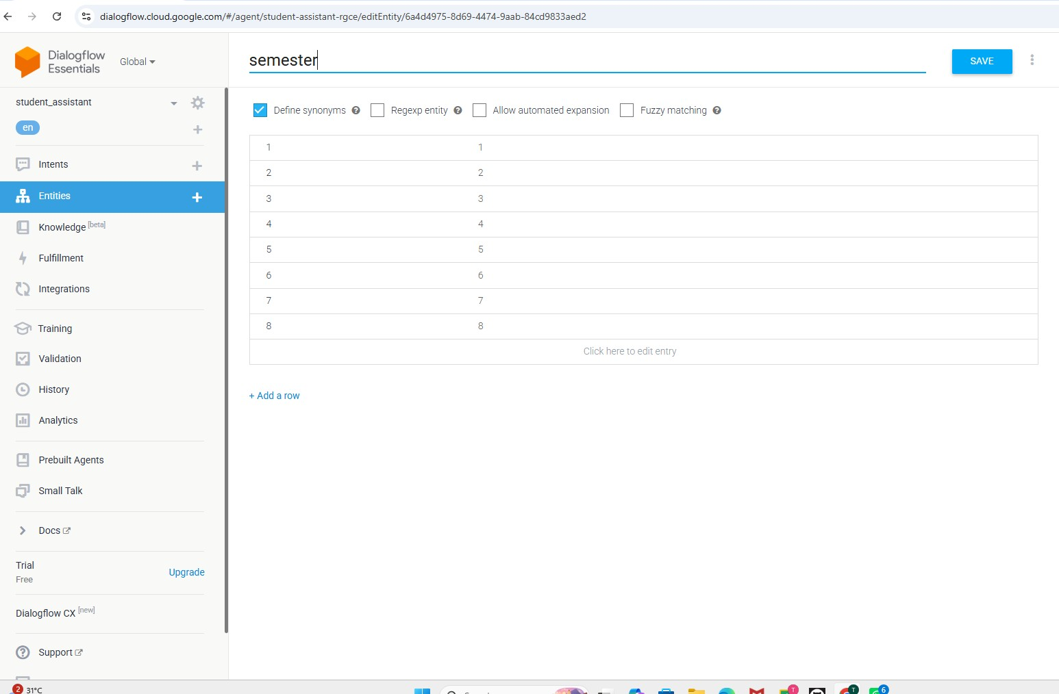
Student chatboxEnd Conversation Fallback Intent Selected Search Strategy Heuristic-Based Search:
D
i
s
p
l
a
y
s
w
e
l
c
o
m
e
m
e
s
s
a
g
e
S
t
u
d
e
n
t
e
n
t
e
r
s
a
q
u
e
r
y
D
e
t
e
c
t
u
s
e
r
i
n
t
e
n
t
R
e
g
i
s
t
r
a
t
i
o
n
A
t
t
e
n
d
a
n
c
e
E
x
a
m
i
n
a
t
i
o
n
S
e
r
v
i
c
e
s
G
e
n
e
r
a
t
e
R
e
s
p
o
n
s
e
I
s
t
h
e
q
u
e
r
y
r
e
s
o
l
v
e
d
?
Y
e
s
N
o
A
s
k
u
s
e
r
t
o
r
e
p
h
r
a
s
e
a
g
a
i
n
For this project, Heuristic-Based Search is selected because Dialogflow ES uses Natural Language Understanding (NLU) and Machine Learning to compare the user's query with the available training phrases and identify the most relevant intent.
Instead of checking every intent one by one, the chatbot estimates the best match using confidence scores.
Why Heuristic Search?
Heuristic search is suitable for conversational AI because it:
- Quickly identifies the best matching intent.
- Reduces response time.
- Improves chatbot accuracy.
- Efficiently handles large numbers of intents.
- Provides a better user experience.
Since Dialogflow ES uses Google's machine learning models, heuristic search is naturally integrated into the intent-matching process.
Advantages of the Developed Chatbot • Provides 24×7 student support.
- Reduces administrative workload.
- Delivers quick and accurate responses.
- Improves communication between students and the university.
- Enhances the overall student experience.
Conclusion:
The AI-Based Student Support Assistant was successfully tested using multiple student queries. The chatbot accurately recognized user intents, generated relevant responses, and handled unknown queries using the Default Fallback Intent. The evaluation demonstrated high intent recognition accuracy, fast response time, and reliable performance. With future enhancements such as database integration and multilingual support, the chatbot can become a comprehensive digital assistant for university students.
